PERSONAL DATA **CSABA MOLNÁR**

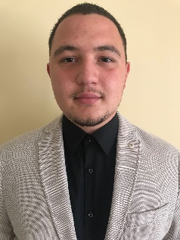

Atilla street 2, Budapest (Hungary)



+36 30 533 0187



mcsaba0624@gmail.com



EXPERIENCE

04 Sep 2017 – Dec. 2020 **Electrical Engineer Dual Trainee**

E.ON Tiszántúli Áramhálózati Zrt., Debrecen (Hungary)

* + - * + Knowledge of distribution and transmission network technology
        + Basic knowledge of LEAN culture
        + Participation in electrical network construction
        + Basic knowledge of project management

01 Feb 2021 – 10. Nov 2022 **Electrical Engineer**

E.ON Tiszántúli Áramhálózati Zrt., Debrecen (Hungary)

Opus Titász Zrt., Debrecen (Hungary)

* + - * + Central and low voltage network construction contract management
        + Contractual obligations inspection
        + Verification of earthwork performance certificates for ground cables and aerial cables
        + Contact person for contractors
        + Preparation and verification of tender materials

13 Nov 2021 – today **Electrical Engineer**

E.ON, Budapest (Hungary)

EDUCATION

11 Sep 2017 – Dec 2020 **Bachelor of Engineering - BE, Electrical and Electronics Engineering**

PERSONAL SKILLS

**Foreign languages**  -English - intermediate level

-Romanian - fluently

**Communication skills** - During my university studies and the completion of dual training, as well as due to continuous contact with clients, I managed to improve my verbal and written communication skills. I use these skills in my current position too, I constantly give presentations to the contracted persons and inform them about current changes.

**Digital skills** - Office programs

- Basic knowledge of Photoshop

- Basic knowledge of AutoCAD

**Driving License** - Category B